To: All Editors and Reporters in Local News/ Business/ Technology Edition

Press Release

**Results of the "Asia Smart App Awards 2022/2023" Announced**

**Hong Kong teams encompass three awards**

**with one Gold, one Silvers and one Bronze**

**Israel wins the Grand Award**

**(Hong Kong, June 30, 2023)** The "Asia Smart App Awards 2022/2023" (ASA), organised by the Hong Kong Wireless Technology Industry Association (WTIA), was held at Cyberport on June 29. This brought together experts and leaders from the fields of smart applications, creativity, and information technology in Hong Kong and 16 Asian countries and regions, to celebrate shared triumphs in innovation.

Hong Kong's contestants demonstrated their prowess in this competition once again, as four out of the nine finalist teams hailed from the city. They contended for the "Public Sector and Social Innovation Category", "Lifestyle & Entertainment Category "and "Business and Commercial Category "along with 5 competitors from Israel, Malaysia, Thailand, and Vietnam. The new "Best Augmented & Virtual Reality App" (Special Mention Award on VR/AR - Best Augmented & Virtual Reality App) which was introduced in this edition, was also won by a Hong Kong company.

This highly-regarded event, which marks its ninth occurrence this year, was sponsored by the "Create Hong Kong" ("CreateHK") initiative of the Hong Kong Special Administrative Region Government. "ASA" stands as a major event in the Asia smart app industry, boasting partnerships from Hong Kong and 16 other Asian regions this year, including the Mainland, Israel, Indonesia, Japan, South Korea, Malaysia, the Philippines, Singapore, Taiwan, Thailand, Vietnam, Sri Lanka, Myanmar, India, Cambodia and Bangladesh. This initiative offers an unparalleled platform for exchange within the Asia smart app industry and also marks the first competition and award presentation to occur in-person after the pandemic.

At this year's award ceremony, The Hon. Duncan Chiu, Legislative Council Member for Technology and Innovation, was invited as a distinguished guest and speaker. He extended his gratitude to the WTIA and other partners for successfully organising this year's awards and congratulated all the triumphant teams. Mrs. Lowell Cho, Assistant Head of CreateHK of the Government of the Hong Kong Special Administrative Region, was invited to officiate and reveal the winners.

Keith Li, Chairman of the WTIA, expressed at the award ceremony, "It brings me great pleasure that we can host this event successfully in the Asian region again and convene experts from 16 Asian countries/ regions after pandemic. This year, participants demonstrated great enthusiasm. Following several rigorous selection stages, representatives from Hong Kong and professional judges from other Asian regions whittled down over 140 shortlisted entries to the top nine. The competition amongst these selected works was intense. These finalist teams underwent a final round of selection this morning in Hong Kong, with 16 industry experts from across Asia countries/ regions jointly assessing to ultimately decide the gold, silver, and bronze awards for each category. One of the gold winners also received the Grand Award to acknowledge their innovative skills and their efforts in smart app development."

The "Asia Smart App Awards 2022/2023" had three main award categories: Public Sector & Social Innovation Category, Lifestyle & Entertainment Category, and Business and Commercial Category. There were nine finalists, which included four from local Hong Kong enterprises. They competed with teams from Israel, Malaysia, Thailand, and Vietnam for the gold, silver, and bronze awards. The gold winners of each award category were further assessed to determine this year's "Asia Smart App Grand Award" recipient. Additionally, the "Asia Smart App Awards" introduces the new "Best Augmented & Virtual Reality App" (Special Mention Award on VR/AR - Best Augmented & Virtual Reality App) starting from this edition, to recognise the outstanding products in the industry that have best utilised virtual/augmented reality. The Award was won by Present AR developed by the team from Hong Kong enterprise, 417 Technology Limited. The app combines AR imaging technology and interactive system, supports human posture, hand gesture recognition, and other natural input, allowing users to express themselves and make the presentation more naturally and smoothly.

The list of the Asia Smart App Awards 2022/2023’s awardees* is as follows:

**Public Sector & Social Innovation Category:**

* Gold Award - Hong Kong: PRAISE-HK-EXP (Institute for the Environment, HKUST)
* Silver Award - Vietnam: BusMap (PHENIKAA MAAS)
* Bronze Award - Thailand: HandySense (National Electronics and Computer Technology Center)

**Lifestyle and Entertainment Category:**

* Gold Award - Israel: Photo Scan by Photomyne (Photomyne)
* Silver Award – Malaysia: Touch 'n Go eWallet (TNG Digital Sdn. Bhd.)

**Business and Commercial Category:**

* Gold Award - Malaysia: Fasstap™ (Soft Space Sdn Bhd)
* Silver Award - Hong Kong: Lalamove Deliver Faster (Easy Mobile Logistics Hong Kong Limited )
* Bronze Award – Hong Kong: ARC Robot Control and Management (R2C2 Limited)

**Asia Smart App Grand Award**

* Israel: Photo Scan by Photomyne (Photomyne)

**(Special Mention Award on VR/AR - Best Augmented & Virtual Reality App)**

Awardee: Present AR, 417 Technology Limited (Hong Kong)

*Please also refer to the official website at <https://contest2022-23.bestasiaapp.hk/>

for further details of the Asia Smart App Awards 2022/2023 and winner list of the Certificate of Merit in each category.

The Hong Kong Wireless Technology Industry Association (WTIA) organises the Asia Smart App Awards (ASA) 2022/2023, the 9th edition following the success of past editions, with funding support from Create Hong Kong of the Government of the Hong Kong Special Administrative Region. The Awards are dedicated to recognising the contributions of industry insiders to the smart app industry, provide a networking platform smart app industry professionals from local to Asia regions, encouraging growth and development within the industry.

WTIA remains committed to enhancing the reach of these awards across Asia, bolstering the development of the local smart app industry, and facilitating local smart app talent in business expansion. The awards have drawn participants from an increasing number of Asian countries and regions, including Hong Kong, the Mainland, Israel, Indonesia, Japan, South Korea, Malaysia, the Philippines, Singapore, Taiwan, Thailand, Vietnam, Sri Lanka, Myanmar, India, Cambodia, and Bangladesh.

Besides the “Asia Smart App Awards 2022/2023” Award Presentation Ceremony, the Asia Smart App Summit was held on the same day. The summit convened expert representatives from 15 Asian countries and regions to engage in discussions about trending topics such as ICT Ecosystem, Start UP: Key factors and challenges and The Rise of AI.

Photo Captions

1. Keith Li, Chairman of the WTIA.

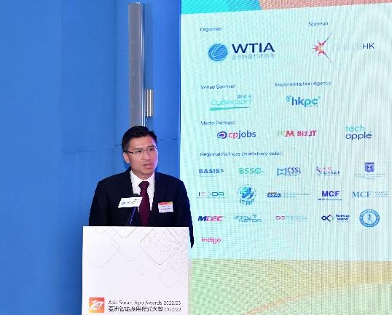

1. The Hon. Duncan Chiu, Legislative Council Member for Technology and Innovation

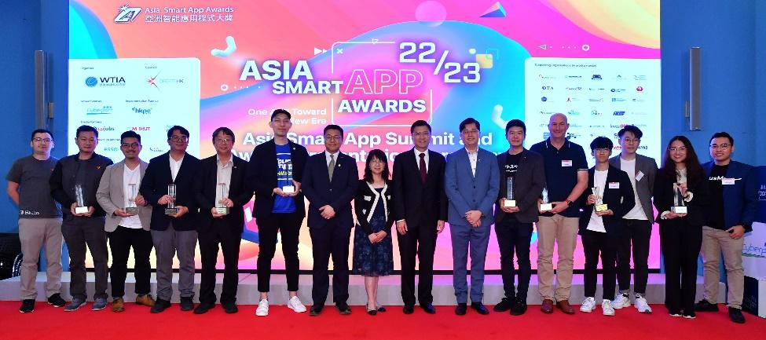

1. Winners and the presenter of the "Asia Smart App Awards 2022/2023"

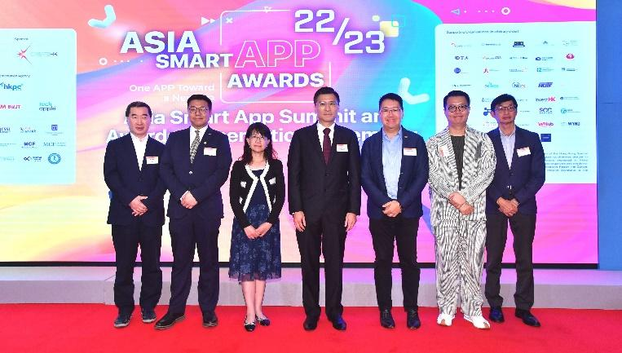

1. (From Left) Mr. Alex Kun, Executive Committee Members of WTIA, Mr. Keith Li, Chairman of WTIA, Mrs Lowell Cho, Assistant Head of CreateHK, Hon. Duncan Chiu, Legislative Council Member, Technology & Innovation Constituency , Mr. Donald Chan, Vice Chairman of WTIA, Mr. Sunny Kwok, Mr. Nelson Tse, Executive Committee Members of WTIA

**For Media Enquiries, please contact**

**Market Hubs Holdings Limited**

| Lierence Li | Ginger Kiang |
| --- | --- |
| +852 2159-4180/ 6110-8495 | +852 2159 4180/ 9271-3974 |
| [lierence@markethubsgroup.com](mailto:lierence@markethubsgroup.com) | ginger@markethubsgroup.com |

**Hong Kong Wireless Technology Industry Association**

| Paula Chui |  |
| --- | --- |
| +852 2989-9163 / 5488-0331 |  |
| paulachui@hkwtia.org |  |

**About Hong Kong Wireless Technology Industry Association**

The Hong Kong Wireless Technology Industry Association (WTIA), established in 2001, is a not-for-profit, politically-neutral trade association dedicated to the wireless and mobile industry. The WTIA acts as a platform, an aggregator, and a community for industry professionals to learn and drive emerging wireless and mobile technologies, governance, and standards. It facilitates networking among likeminded professionals, boost interoperability between networks and devices, and strives to help all organizations apply these technologies to existing or new businesses. The WTIA also represents and is supported by digital industries pertaining to mobile such as digital entertainment, digital marketing and media, and start-up sectors. To know more about the WTIA, please visit <http://www.hkwtia.org>.

**About Asia Smart App Awards (ASA)**

The Hong Kong Wireless Technology Industry Association (WTIA) organises the Asia Smart App Awards (ASA) 2022/2023, the 9th edition following the success of past editions, with funding support from Create Hong Kong of the Government of the Hong Kong Special Administrative Region. By uniting 16 co-organisers from Bangladesh, Cambodia, Israel, India, Indonesia, Japan, Korea, the Mainland, Malaysia, Myanmar, Philippines, Singapore, Sri Lanka, Taiwan, Thailand, and Vietnam, in addition to Hong Kong, the ASA carries this auspicious occasion to further encourage the development of the expanding smart application industry. For more details about the ASA, please visit [www.bestasiaapp.hk](http://www.bestasiaapp.hk).

**About Create Hong Kong**

Create Hong Kong (CreateHK) is a dedicated office set up by the Government of the Hong Kong Special Administrative Region in June 2009 to spearhead the development of creative industries in Hong Kong. From 1 July 2022 onwards, it is under the Culture, Sports and Tourism Bureau. Its strategic foci are nurturing talent and facilitating start-ups, exploring markets, promoting cross-sectoral and cross-genre collaboration, and promoting Hong Kong as Asia’s creative capital and fostering a creative atmosphere in the community. CreateHK sponsors the Asia Smart App Awards (formerly known as the Asia Smartphone Apps Contest) to promote the development and use of smart apps among Hong Kong’s creative industries. CreateHK’s Website: <http://www.createhk.gov.hk>.